



Table of Contents

**Executive Summary:** **2**

**MILESTONE 1:** **2**

**PROBLEM SUMMARY/PROPOSED SYSTEM REQUIREMENTS:** **2**

**Feasibility Analysis:** **5**

Technical Feasibility: 5

Economic Feasibility: 6

Organizational Feasibility: 8

**Project Plan:** **9**

**MILESTONE 2:** **11**

**Use Cases:** **11**

**Process Model:** **21**

**Bike Hold Notification (Michael Hansen)- Context diagram** **23**

**Bike Hold Notification (Michael Hansen)- Level 0 DFD** **23**

**Entity Relationship Diagram:** **28**

Grading/Checkoff Sheet – Milestone 2 29

**END OF REQUIREMENTS FOR MILESTONE 2 REPORT** **29**

**MILESTONE 3** **30**

**Interaction Screens:** **30**

# Executive Summary:

USF recreation needs help with their back-end operations which includes: keeping track of their bikes, customers/users, and reduce expenses and loss costs associated with the Share-A-Bull Bikes program. We propose to implement a Bike GPS Information System to assist USF recreation with daily operation functionality, while also keeping direct costs down. The project’s size will be relatively small given that we are only building upon a preexisting system. We estimate this project to be approximately 95% feasible with a positive net present value (NPV) of $22,489 which will actually add value to the bike program. We have determined that the program will break-even in 3.63 years. From an organizational perspective, this project is considered low risk with high return on investment.

The implementation of the project will have a number of user interaction screens. Interactions screens are displayed for both user feedback and the GPS feature of the bike. The feedback interaction screen allows users to comment on their experience with several types of questions. The GPS feature of the user interface will allow users to see every available bike in the area. Users may also select which bike they would like to reserve, and the GPS feature will provide directions from the user’s current location, to the current location of the desired bike. The two types of interaction screens are few of the many capabilities of the interface that will be produced from this project.

# MILESTONE 1:

# PROBLEM SUMMARY/PROPOSED SYSTEM REQUIREMENTS:

The purpose of this requirements document is to provide documentation to prospective Share-A-Bull bike reservation providers on the requirements of implementing and operating a Bike GPS Information System. This Requirements Document will outline the user, functional, and non-functional system requirements identified by the Share-A-Bull bike executive team as the proposed information system solution for a Bike GPS Information System

User Requirements:

1. Keep an account of all the members with membership details and account history. The data should be accessible at any time and without much delay.

2. Gather data about the peak hours and peak routes so that the management can take a call on whether to increase the number of bikes or to devise a new plan for redistribution of bikes around the campus.

a. Manage the bike inventory and usage statistics

3. Send out alerts to users whenever the free ride time is about to expire, a bike is being locked outside of campus premises and whether a particular bike has been kept on hold.

4. The “Share-A-Bull Bikes” program is funded by the Student Green Energy Fund and their office would like to know the daily cost of operation and the major contributing factors which could be optimized to bring down the overall cost.

5. Obtain rider/user feedback so that any anomalies can be addressed.

Functional Requirements:

1) On User requirement 1:

a) The system should be able to generate an account number for all existing and new users

b) The system should be able to pull all data by account number

c) The system should be able to retain 4 years of user history

d) The system should be able to have a date feature so loading time can be quick

e) The system should be able to populate data within 5 minutes

2) On user requirement 2:

a) The system should keep a database of all bikes interchangeably between a unique bike # and GPS #

b) The system should be able to generate peak times bikes are in use

c) The system should be able to track the GPS location and store it periodically

d) The system should be able to pull the real-time location of the bikes

e) The system should be able to show the peak routes by day, week, and month

f) The system should be able to relate peak/non-peak times with weather and major events

3) On User requirement 3:

a) The system should utilize GPS function to know location of bikes

b) The system should know when a bike is in use

c) The system should be able to time users

d) The system should send an SMS or push notification through the app already in use 10 minutes before the time is expired

e) The system should send an SMS or push notification when the bike is beyond location limits

f) The system should know what locations are out of range

g) The system should alert Share-A-Bull when a bike has been held for more than 5 minutes after reservation time

h) The system should give bike user the option to extend their time

i) The system should be able to store data of bike users who ignore their warning messages

4) On user requirement 4:

a) The system should know the cost of each bike by bike #

b) The system should know which bikes receive maintenance

c) The system should generate on report on weekly maintenance of bikes

d) The system should track all accidents of bikes by bike #

e) The system should utilize the GPS to know what locations accidents occur

f) The system should know the type of maintenance each bike receives

g) The system should know the cost of repair for bikes that have been in accidents

h) The system should prompt user to take a picture of the bike and upload into the app before and after riding

i) The system should keep a record of users that do not take a picture of the bike

5) On user requirement 5:

a) The system should be able to ask bike users to take a survey

b) The system will ask a series of close ended emotional scale questions (scales of 1-5, 1 being the least, 5 being the most)

c) The system should provide discounts and coupons to users that do take the survey

d) The system should allow the user to provide comments on their ride

Non-Functional Requirements

1. The system needs to have a search engine to look up account history

2. The system needs to update and function in real time

3. The system needs to have a separate search engine to look up bikes/GPS numbers

4. The system needs to store about 1 terabyte of data

5. The system needs to connect with news and weather sites

6. The system needs to know what range the bikes are permitted in

7. The system needs to have photo capabilities

8. The system needs to have SMS or push notification capabilities

9. The system needs to generate daily/weekly/monthly reports of peak routes and send to user by email

10. The system needs to pull data from the GPS

11. The system needs to pull data from both iOS and Android technology

12. The system needs to know hours of operation

13. The system needs to know what bikes are reserved

14. The system needs to know who the bikes are reserved to

15. The system needs to know how long the bike is reserved for

16. The system needs to know all current reservation specials are going on

17. The system needs to know when a bike needs maintenance

18. The system needs to generate questions to get emotional feedback from students

19. The system needs to take those numbers and average out to determine the overall satisfaction of bike users

20. The system needs to determine what bikes have been in an accident through police/student reports

# 

# 

# Feasibility Analysis:

## Technical Feasibility:

For this project, The Share-A-Bull Bike program from USF would like to keep an account of all members with their account information, gather data at peak hours and routes, notify bikers when their free time is about to expire, and manage bike inventory. The project for this application will be familiar to other projects since these features will be built on top of the existing application. The type of technology needed to program a feature for students to check on their account information is available at our disposable. The technology used will be java for android applications and swift for iOS applications, which are languages our USF team has had experience with along with MySQL which is needed for the database. The project size will be relatively small, needing only two programmers, a UI designer, and a database administrator. The compatibility risk for this project is relatively small. The features that are wanted for this project will be added features on top of the existing application making the integration for this system relatively easier. The estimated degree for the feasibility of this project is around 95%.

## 

## 

## 

## 

## Economic Feasibility:

Based on the below information, this is a feasible project. The positive NPV of 22,489 indicates that the project will have value added to the business. It will increase overall profits. We have determined that the break-even occurs in 3.63 years.

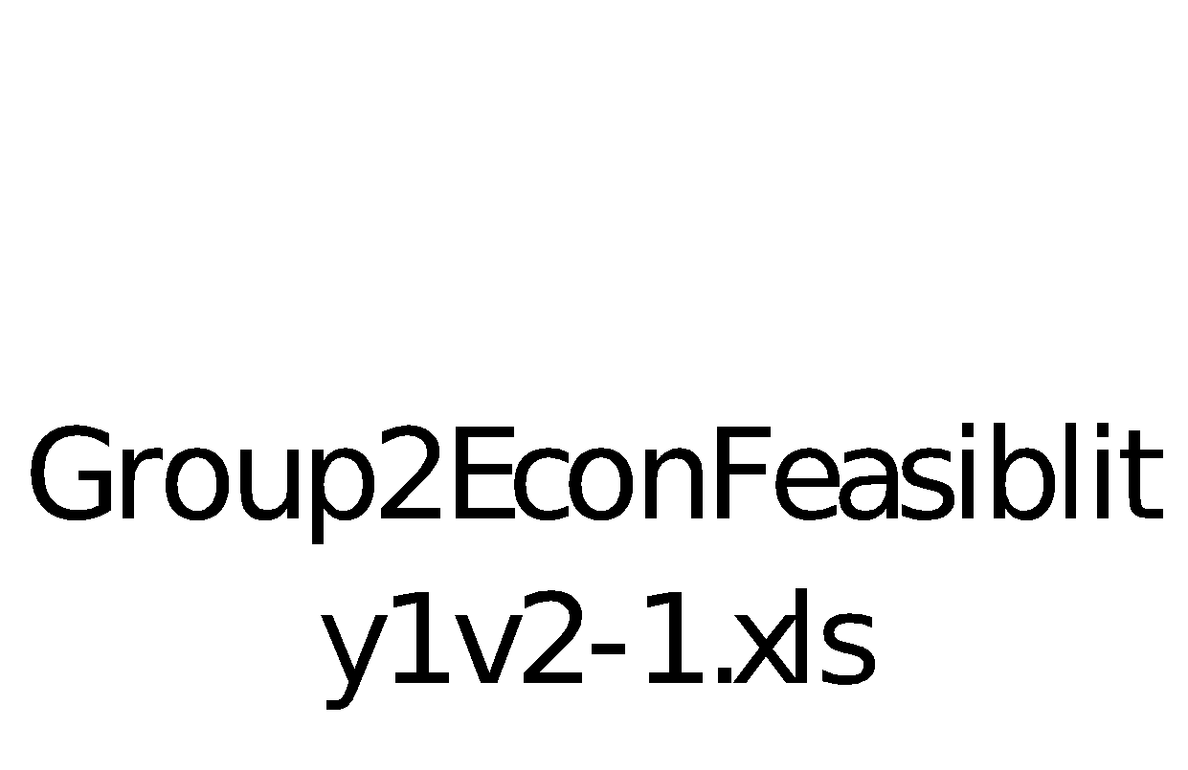

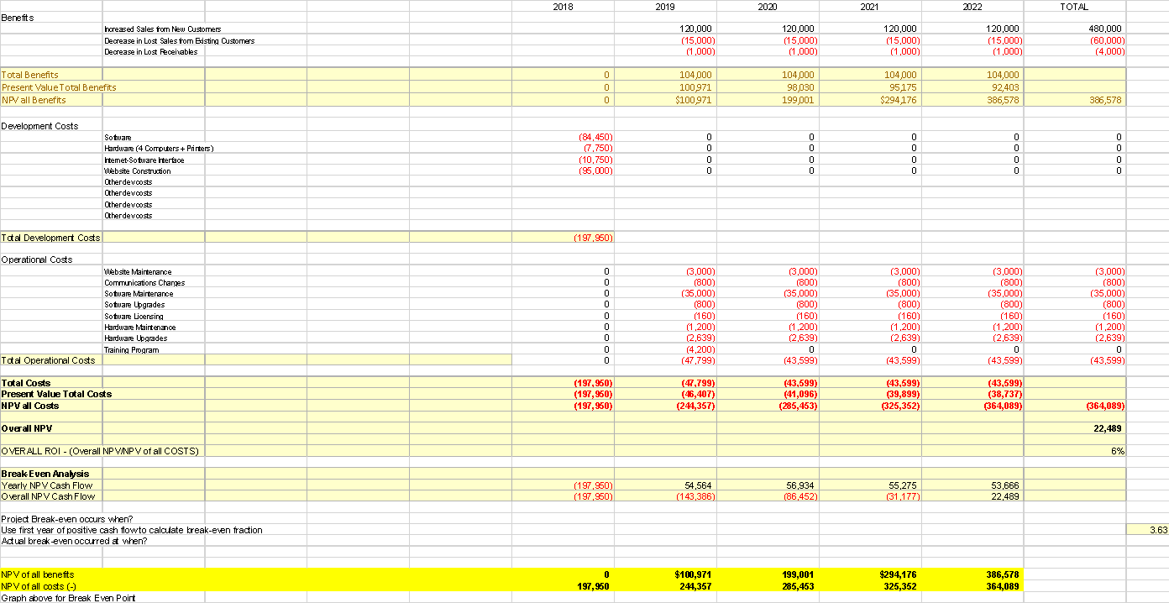

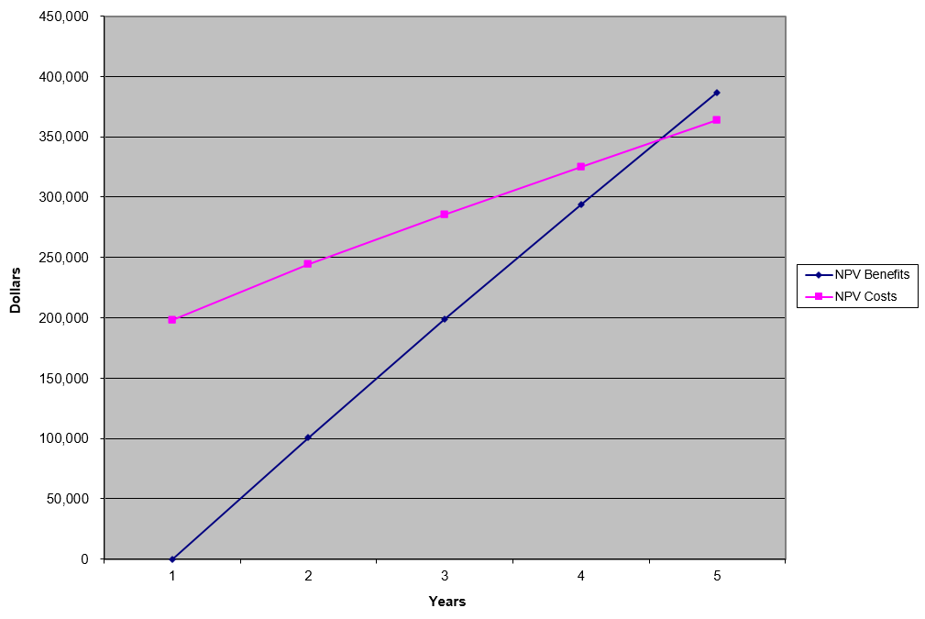

## Organizational Feasibility:

From an organizational perspective, this project is considered low risk. The top managers of this company have a strong interest in this project. The project champion, Denis Edwards, has notable experience in making, changing, and implementing systems inside of corporations.

The users of this system, in this case management, are expected to know how the system works with current operations. We would have to keep them notified throughout the creation of this system. When the system is made however, the managers will have a good source of new data for them to make better choices on the direction the company should go.

# Project Plan:

|  |  |  |  |  |  |  |  |  |  |  |
| --- | --- | --- | --- | --- | --- | --- | --- | --- | --- | --- |
|  |  |  | **Estimated** | | | **Actual** | | |  |  |
| Task ID | Task Name | Assigned To | Duration  (days) | Start Date | Finish Date | Start Date | Finish Date | Duration Variance | Dependency | Status |
| 1.1 | Determine Group name | ALL | 35 | 1/15 | 2/19 | 1/15 | 2/19 | 0 | No | C |
| 1.2 | Table of contents | ALL | 35 | 1/15 | 2/19 | 1/15 | 2/12 | -7 | No | C |
| 1.3 | Executive summary | Kira | 35 | 1/15 | 2/19 | 1/15 | 2/19 | 0 | S | C |
| 1.4 | Problem summary/system requirements | Destiny | 35 | 1/15 | 2/19 | 1/15 | 2/12 | -7 | P | C |
| 1.5 | Technical feasibility | Michael | 35 | 1/15 | 2/19 | 1/15 | 2/12 | -7 | P | C |
| 1.6 | Economic feasibility | Louis | 35 | 1/15 | 2/19 | 1/15 | 2/12 | -7 | P | C |
| 1.7 | Organizational feasibility | Demetre | 35 | 1/15 | 2/19 | 1/15 | 2/12 | -7 | P | C |
| 1.8 | Project plan | Destiny and Kira | 35 | 1/15 | 2/19 | 1/15 | 2/19 | 0 | P | C |
| 1.9 | Grading/checkoff sheet for milestone 1 | ALL | 49 | 2/19 | 4/23 | 2/19 | 4/9 | 0 | No | C |
| 2.1 | Updated executive summary | Louis | 49 | 2/19 | 4/9 | 2/19 | 4/9 | 0 | S | C |
| 2.2 | Use cases | ALL | 49 | 2/19 | 4/9 | 2/19 | 4/9 | 0 | P | C |
| 2.3 | Process models | Demetre, Destiny, Louis | 49 | 2/19 | 4/9 | 2/19 | 4/9 | 0 | S | C |
| 2.4 | Entity relationship diagram | Caleb | 49 | 2/19 | 4/9 | 2/19 | 4/9 | 0 | P | C |
| 2.5 | Data Dictionary and Metadata | Kira, Michael | 49 | 2/19 | 4/9 | 2/19 | 4/9 | 0 | S | C |
| 2.6 | Grading/Checkoff Sheet for Milestone 2 | ALL | 49 | 2/19 | 4/9 | 2/19 | 4/9 | 0 | No | C |
| 3.1 | Revised Milestone 1&2 | ALL | 14 | 4/9 | 4/23 | 4/9 | 4/9 | 0 | No | C |
| 3.2 | Interaction screens | Caleb ,Louis | 14 | 4/9 | 4/23 | 4/9 | 4/23 | 0 | P | C |
| 3.2a | Example input screen | Caleb, Louis | 14 | 4/9 | 4/23 | 4/9 | 4/23 | 0 | S | C |
| 3.2b | Example output screen | Caleb, Louis | 14 | 4/9 | 4/23 | 4/9 | 4/23 | 0 | S | C |
| 3.2c | One example printed summary report with example data | Caleb, Louis | 14 | 4/9 | 4/23 | 4/9 | 4/23 | 0 | S | C |
| 3.3 | Grading/Checkoff Sheet for Milestone 3 | ALL | 14 | 4/9 | 4/23 | 4/9 | 4/23 | 0 | No | C |

**Key**

**TBD**: To Be Decided

**Duration Variance**: Actual- Estimated time (Negative numbers indicate task completion in less time)

**Dependency**: P (Predecessor) and S (Successor), No for neither

*\*Note: P and S are not in order*

# MILESTONE 2:

# Use Cases:

|  |  |  |  |  |  |  |
| --- | --- | --- | --- | --- | --- | --- |
| Use Case Name: **Bike Maintenance (Destiny Bonilla)** | | | ID: **UC_1** | | **Priority: Medium** | |
| Brief Description:  **When bicycles are in need of repair/maintenance, the system notifies the company to send the bike to the repair shop.** | | | | | | |
| Actor: Bike Mechanic | | | | | | |
| Trigger: **More than a week without maintenance**  Type ¨ External **X Temporal** | | | | | | |
| Preconditions:  **1. The system knows the location of the Bike**  **2. The system is set for weekly maintenance for all Bikes**  **3. Registered users have opted to submit photos of Bike**  **4. Mapping system is online and available**  **5. Maintenance system is online and available** | | | | | | |
| Normal Course:  **1.0 Bike goes without maintenance for over a week**  **2.0 System notifies Mechanic a particular bike is in need of repair**  **3.0 System removes bike from available inventory**  **4.0 System updates bike to “in repair”**  **5.0 Bike Mechanic retrieves bike**  **6.0 Bike is repaired**  **7.0 Metrics for the bike maintenance is updated**  **8.0 Bike Mechanic returns bike to a share-a-bull bike location**  **9.0 System reinstates bike to available inventory** | | | | Information for Steps    **<-Bicycle id, location Ids**  **<- location of bikes**  **<- Mechanic ID**  **<- Inventory of bikes**  **<- Time span of maintenance for Bikes** | | |
| Alternative Course(s):  **1. No Bike mechanic available to intake bike for repair**  **a. The system notifies registered administrator that there is currently no available bike mechanic**  **b. Administrator makes a note that the bike will be out of inventory for longer than normal**  **c. Resume step 3** | | | | | | |
| Postconditions:  **1. Maintenance status at both locations are updated**  **2. Update bike usage time for maintenance** | | | | | | |
| Exceptions: | | | | | | |
| Summary:  Inputs Source Outputs Source | | | | | | |
| **Registered Mechanic**  **Location Ids**  **Current Inventory Level**  **Bicycle location**  **Maintenance time span** | **Share-A-Bike System**  **Share-A-Bike System**  **Share-A-Bike System**  **Share-A-Bike System**  **Share-A-Bike System** | **Notification message to Mechanic** | | | |  |

|  |  |  |  |  |  |  |
| --- | --- | --- | --- | --- | --- | --- |
| Use Case Name: **Free time expiration notification to user (Michael Hansen)** | | | ID: **UC_2** | | **Priority: High** | |
| Brief Description: **When a user’s free ride time is about to expire, the system will notify the user of the free ride time expiration.** | | | | | | |
| Actor: Registered users | | | | | | |
| Trigger: **User free ride time is about to expire. User is outside campus premises. Specific bike user is requesting is on hold.**  Type ¨ External **X Temporal** | | | | | | |
| Preconditions:  **1.** **Free time rides for the user is known to the system**  **2.** **Bikes are tracked in Real time.**  **3.** **Mapping system is online and available**  **4.** **Cycle rental system is online and available**  **5.** **Bike User’s email is online and available**  **6.** **Bike User’s credit card is available** | | | | | | |
| Normal Course:  **1.0** **Alert registered users on free time expiration**  **1.1** **The system determines that the users free ride time is about to expire**  **1.2** **The system will notify the user that their free ride time is about to expire**  **1.3** **Registered users that receive the notification from the system can either drop the bike at the nearest ride a bull bike stop or pay for extra bike time** | | | | Information for Steps    **<- Free ride time expiration**    **<- Registered users that are within one cycle location and have expired free time.**  **<- Registered users cell number**  **<-Closest location to the registered user** | | |
| Alternative Course(s):  **1.** **If the Registered User goes past the expired free time. The Registered user will be charged a fee.**  **a.** **The system notifies registered users that they are charged a fee for going past the expiration date.** | | | | | | |
| Postconditions:  **1.** **Registered Users account is notified on payment options**  **2.** **Registered User account is updated** | | | | | | |
| Exceptions:  **1.** **If bike that was placed on hold has not been used within a certain amount of time, the registered user will be notified of bike on hold**  **2.** **Registered user will have the option of keeping the bike on hold or allowing the bike to open for other registered users.** | | | | | | |
| Summary:  Inputs Source Outputs Source | | | | | | |
| **Registered user**  **Location Ids**  **Campus Premises**  **Bicycle location**  **Registered user location**  **User free time** | **Share-A-Bike System**  **Share-A-Bike System**  **Share-A-Bike System**  **Share-A-Bike System**  **Share-A-Bike System**  **Share-A-Bike System** | **Notification message to registered user** | | | |  |

|  |  |  |  |  |  |  |
| --- | --- | --- | --- | --- | --- | --- |
| Use Case Name: **Bicycles Authorized Location** | | | ID: **UC_3** | | **Priority: High** | |
| Brief Description: **When bicycles are outside bounded areas, notify registered users and ask them to move the bicycles to areas where bicycles are authorized to operate.** | | | | | | |
| Actor: Registered users | | | | | | |
| Trigger: **User is outside campus premises**  Type ¨ External **X Temporal** | | | | | | |
| Preconditions:  **1. Predetermined boundary**  **2. GPS on bike**  **3. Real time tracking of bike**  **4. Mapping system is online and available**  **5. System to track user and notify if outside zone** | | | | | | |
| Normal Course:  **1.0 Alert registered users**  **1.1 The system determines that the user is outside the authorized area**  **1.2 User is immediately notified when out of approved location**  **1.3 Notification prompts user to turn around** | | | | Information for Steps    **<- track user via GPS**    **<- users register cell phone for notifications**  **<- Registered user notification that they will participate** | | |
| Alternative Course(s):  **1. User does not return the bike to the appropriate location boundaries**  **a. The system notifies the user they are out of bounds**  **b. A penalty could be added to the account**  **c. Varying how far the user strays determines the penalty amount** | | | | | | |
| Postconditions:  **1. Bike being tracked in real time**  **2. User being tracked in real time**  **3. Registered users have valid payment method**  **4. Registered user has valid cellphone to receive alerting of any penalties or invalid location** | | | | | | |
|  | | | | | | |
| Summary:  Inputs Source Outputs Source | | | | | | |
| **Registered user**  **Location IDs**  **Bicycle location**  **Registered user location**    **Register user phone** | **Share-A-Bike System**  **Share-A-Bike System**  **Share-A-Bike System**  **Share-A-Bike System**    **Share-A-Bike System** | **Notification message to registered user** | | | |  |
|  |  |  |  |  |  |  |

|  |  |  |  |  |  |  |
| --- | --- | --- | --- | --- | --- | --- |
| Use Case Name: **Bike hold notification sent to users (Michael Hansen)** | | | ID: **UC_4** | | **Priority: Medium** | |
| Brief Description: **The user will also be notified by the system if a specific bike is on hold by another registered user.** | | | | | | |
| Actor: Registered users | | | | | | |
| Trigger: **Registered User puts a designated bike on a hold.**  Type ¨ External **X Temporal** | | | | | | |
| Preconditions:  **1. High traffic areas and times are known to the system**  **2. Bike holds for a user is known to the system**  **3. Registered users have opted to allow the system to track their location when not using a bicycle**  **4. Offer value for registered users to move cycles is known to the system**  **5. Mapping system is online and available**  **6. Cycle rental system is online and available**  **7. Registered user’s payment systems is online and available** | | | | | | |
| Normal Course:  **1.0 Bike on hold**  **1.1 Registered User puts a bike on hold.**  **1.2 The system notifies other users in the area that a specific bike is on hold**  **1.3 Registered user uses bike that was on hold**    **2.0 User puts bike off hold**  **2.1 Registered User goes to designated area**  **2.2 Registered User notifies the system that they do not need the bike**  **2.3 System notifies other users that bike is not on hold anymore**    **3.0 System notifies user that bike has been on hold for < 30 minutes**  **3.1 Registered User will have the option of keeping the bike on hold or allowing the bike to open for other registered users.**  **3.2 Registered User can keep bike on hold if he chooses that option**  **3.3 If Registered User selects to put bike off hold, system notifies other users that the bike is available for use.** | | | | Information for Steps  **<- Bicycle Id that registered user selects, registered user’s location, hold on bike’s location.**          **<-Bicycle id, location Ids**          **<- Bicycle Id that registered user selects, registered user’s location, hold on bike’s location.** | | |
| Alternative Course(s):  **1. If another registered user uses a bike that is on a hold from another user.**  **a. The system notifies the user that the specific bike is on hold**  **b. Bike user will be charged**  **c. System resumes to step 1** | | | | | | |
| Postconditions:  **1. Registered User account is updated**  **2. Registered User is notified when bike is not hold anymore** | | | | | | |
| Exceptions: | | | | | | |
| Summary:  Inputs Source Outputs Source | | | | | | |
| **Registered user**  **Location Ids**  **Bicycle location**  **Registered user location**  **Bikes that are on hold by location** | **Share-A-Bike System**  **Share-A-Bike System**  **Share-A-Bike System**  **Share-A-Bike System**  **Share-A-Bike System** | **Notification message to registered user** | | | |  |

|  |  |  |  |  |  |  |
| --- | --- | --- | --- | --- | --- | --- |
| Use Case Name: **Obtain rider/user feedback (Louis Crouch)** | | | ID: **UC_5** | | **Priority: Medium** | |
| Brief Description: **After users have finished using the Ride-A-Bull service, they will give feedback in regards to the service, and bicycle used.** | | | | | | |
| Actor: Registered users | | | | | | |
| Trigger: **User completes their rental of the bike.**  Type  **X External** o Temporal | | | | | | |
| Preconditions:  **1. Full rental of bicycle is completed**  **2. Registered users have opted to allow the system to track their location when not using a bicycle**  **3. User is in good standing with the service.**  **4. Mapping system is online and available**  **5. Cycle rental system is online and available** | | | | | | |
| Normal Course:  **1.0 Alert registered users**  **1.1 The system determines that the user has completed the full rental of the bicycle.**    **1.2 The system then notifies the user that feedback is requested on the service.**  **2.0 Feedback form sent to user**  **2.1 The user can either accept to complete the feedback form, or put it off for a later date.**    **2.2 The registered user fills out the feedback form and submits.** | | | | Information for Steps    **<- This notifies the system that the bike in use has had the rental completed.**  **<- This sends a request to the user to complete the feedback form.**    **<- This inquires whether or not the user would like to complete the feedback form.**  **<- This sends the submitted feedback back to the system to be reviewed.** | | |
| Alternative Course(s):  **a. If the network is down**  **i. User should will be requested to go to the Ride-A-Bull website to complete feedback.** | | | | | | |
| Postconditions:  **1. Feedback is received in the system**  **2. Update status of user to having completed feedback**  **3. Registered user accounts are updated to reflect the offer received**  **4. Registered user receives a text message alerting them their feedback has been received** | | | | | | |
| Exceptions: | | | | | | |
| Summary:  Inputs Source Outputs Source | | | | | | |
| **Registered user**  **Location ID**  **User feedback on service**  **location**  **Bicycle location** | **Share-A-Bike System** | **Notification message to registered user that feedback was received** | | | |  |

|  |  |  |  |  |  |  |
| --- | --- | --- | --- | --- | --- | --- |
| Use Case Name: **Peak Usage Hours and locations** | | | ID: **UC_6** | | **Priority: Low** | |
| Brief Description: **This use case describes the times in which the bicycles are in use the most and on which bicycle route.** | | | | | | |
| Actor: Registered users | | | | | | |
| Trigger: **Bike inventory is especially low during these hours.**  Type ¨ External **X Temporal** | | | | | | |
| Preconditions:  **1. System should generate all current and new registered users**  **2. Inventory is identified with a bike number and GPS number**  **3. Track the GPS location and store information**  **4. System can pull real-time location of bikes on routes**  **5. System should be able to show routes and how often they are used**  **6. Mapping system is online and available** | | | | | | |
| Normal Course:  **1.0 A request goes in to rent a bicycle.**  **1.1 System checks availability of bikes with respect to user’s location**  **1.2 System alerts user that bike is or is not available**  **1.3 The system records when large portions of inventory are in use.**  **1.4 The system will notify Campus Recreation when inventory is at its lowest at particular times of the day.**  **1.5 If inventory is available, user follows normal rental steps**    **2.0 Inventory Available**  **2.1 Registered user selects a bike from their location**    **2.2 The system sends a notification of the nearest available bike.**    **2.3 If bike is unavailable at any given time, system records this.**  **2.4 The registered user must wait until a bike becomes available.**  **2.5 If inventory is available, user follows normal prompts to rent bike.** | | | | Information for Steps    **<- Registered user request**  **<- Bike GPS and user’s location**    **<- System Inventory Check**      **<-System Inventory usage alert**  **<- Inventory availability**    **<- Personal GPS**    **<- Registered user receives mobile updates**    **<- Inventory tracking**  **<- Bicycle availability sends out notification to user** | | |
| Alternative Course(s):  **1. All routes are high in traffic with the majority of the bike inventory**  **a. The system notifies users of unavailable bikes and suggests a waitlist in the order in which they received the request.**  **b. Once bike becomes available, resume normal course with step 2.0** | | | | | | |
| Postconditions:  **1. Inventories at all locations are updated daily**  **2. Update waitlist for users in line**  **3. Update bike usage times and locations at peak times**  4. **Registered user’s accounts are notified when a bike becomes available** | | | | | | |
| Exceptions: | | | | | | |
| Summary:  Inputs Source Outputs Source | | | | | | |
| **Registered user**  **Location Ids**  **Offer Value**  **Current Inventory Level**  **Low inventory level by location**  **Bicycle location**  **Registered user location**  **Peak use times by location** | **Share-A-Bike System**  **Share-A-Bike System**  **Share-A-Bike System**  **Share-A-Bike System**  **Share-A-Bike System**    **Share-A-Bike System**  **Share-A-Bike System**    **Share-A-Bike System** | **Notification message to registered user** | | | |  |
|  |  |  |  |  |  |  |

# Process Model:

**Bike Maintenance (Destiny Bonilla) - Context Model**

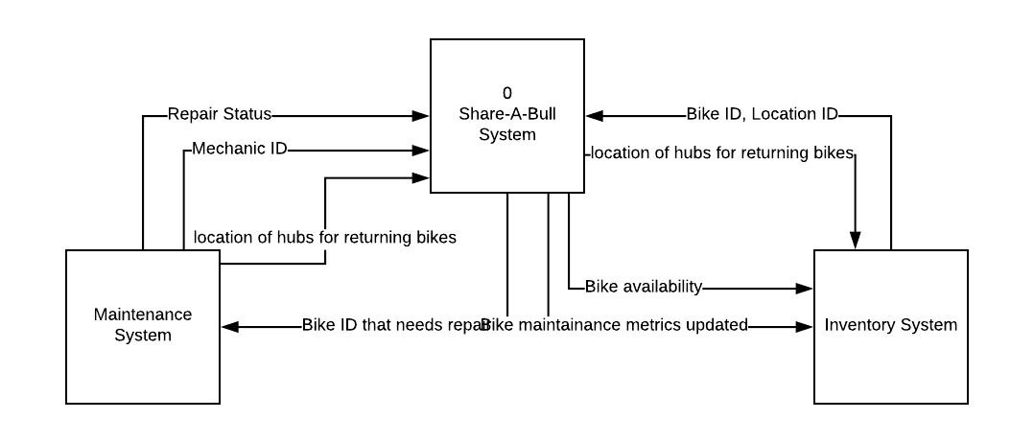

**Bike Maintenance (Destiny Bonilla) - Level 0 DFD**

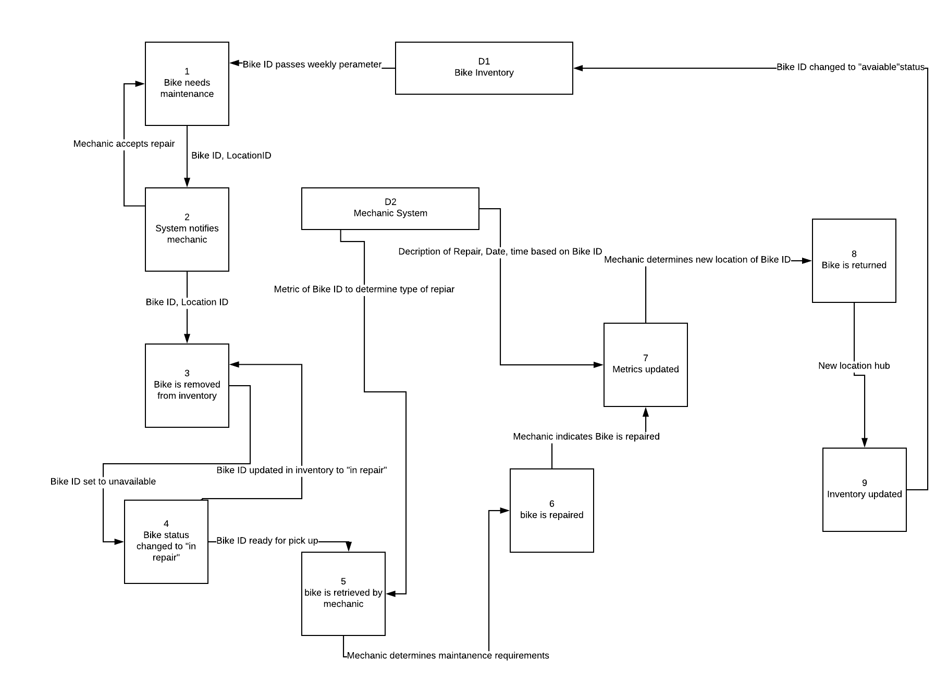

**Free time expiration notification to user (Demetre Riles) - Context Model**

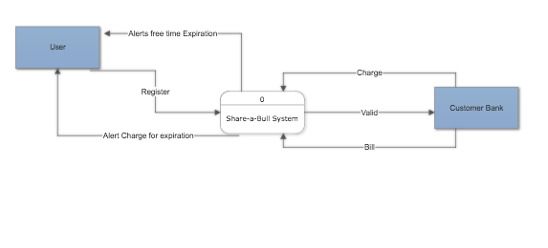

**Free time expiration notification to user (Demetre Riles) - Level 0 DFD**

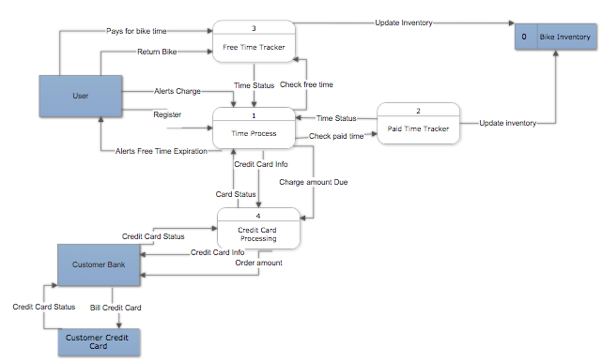

# **Bike Hold Notification (Michael Hansen)- Context diagram**

# 

# **Bike Hold Notification (Michael Hansen)- Level 0 DFD**

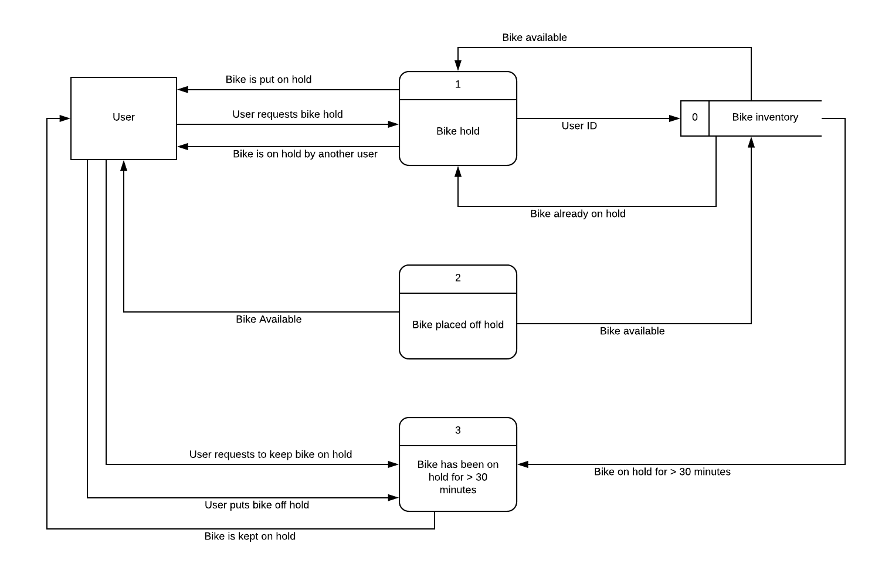

# 

# 

**Obtain rider/user feedback Context Diagram**

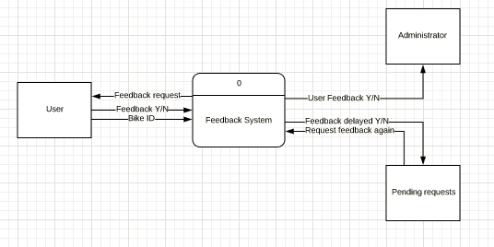

**Obtain rider/user feedback Level 0 Diagram**

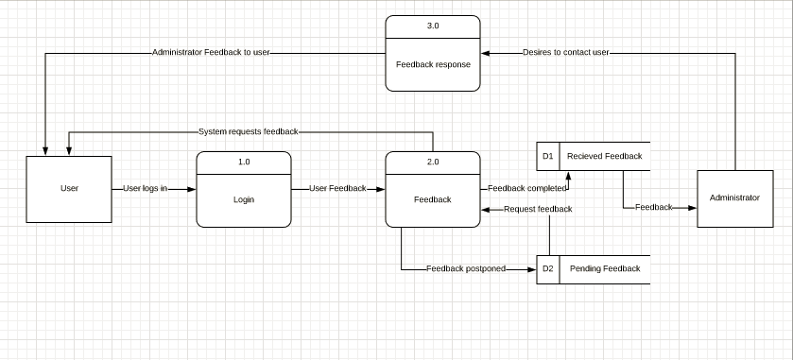

# 

**Bicycles Authorized Location Context Diagram**

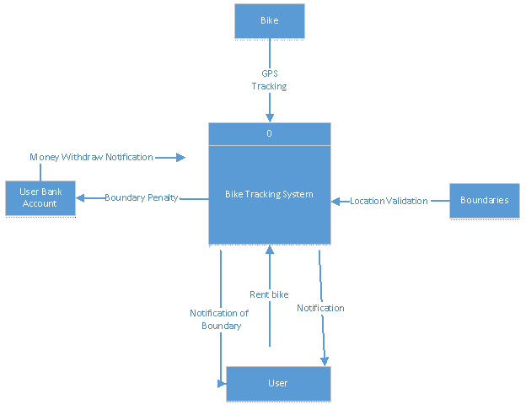

**Bicycles Authorized Location Level 0 Diagram**

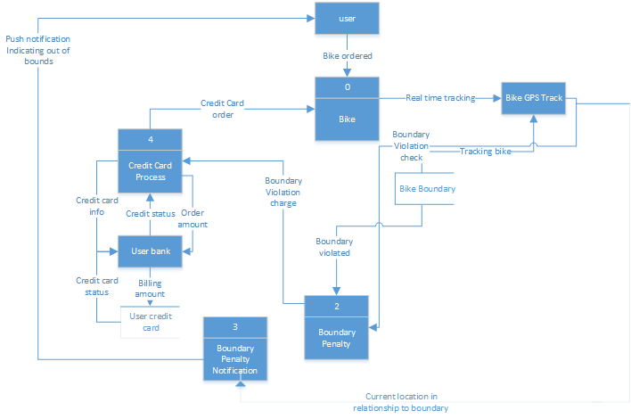

**Peak Usage Hours and locations Context Diagram**

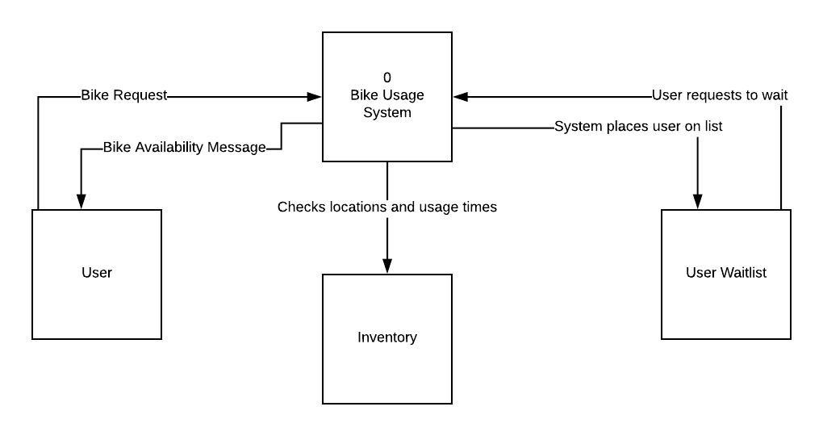

**Peak Usage Hours and locations Level 0 Diagram**

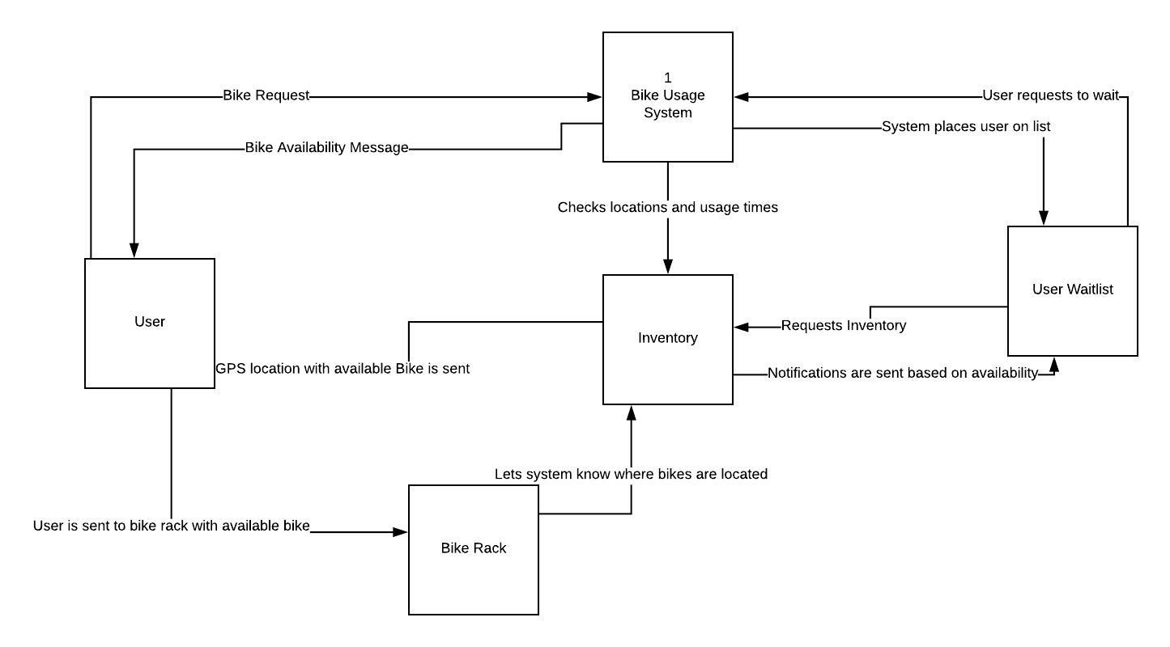

# Entity Relationship Diagram:

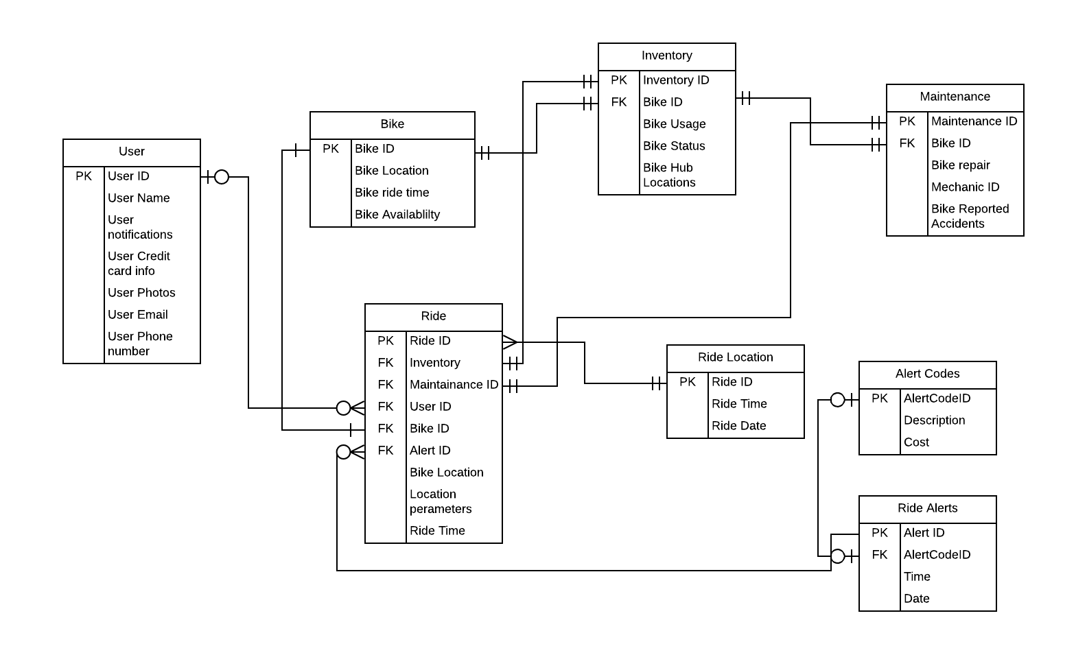

Please review the following grading/checkoff sheet to ensure all deliverables are included before submission.

## Grading/Checkoff Sheet – Milestone 2

1. **UPDATED EXECUTIVE SUMMARY _____**
2. **ANALYSIS (continued)**
3. Use Cases _____
4. List of Use Cases _____
5. Process Models
   * 1. Context Level Data Flow Diagram _____
     2. Level-0 Diagram _____
   1. ERD _____
6. **MEETING MINUTES _____**

# END OF REQUIREMENTS FOR MILESTONE 2 REPORT

# MILESTONE 3

# Interaction Screens:

